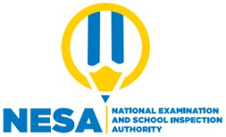

Date: **13/04/2024**

No : **S6/076162/NESA/11/2023**

# CONFIRMATION OF RESULTS

I, the undersigned, NZEYIMANA Jean Claude , Head of Basic Education and TVET Examinations Department of National Examination and School Inspection Authority, certify that the candidate mentioned below sat for Rwanda National Examinations in the school year 2022/2023 and obtained the following grades

Candidate's Names: **NYIRAHABIMANA Ruth**

School attended: Combination/Option: Index Number:

# 570404 - GS RANGO

**Mathematics-Economics-Geography 570404MEG0062023**

Student Number: **411101190037**

# Subject Grade Letter

1. General Studies and Communication Skills **S**
2. Geography **A**
3. Mathematics **S**
4. Entrepreneurship **A**
5. Economics **B**

Weighted aggregate: **45** Mention: **PASS**

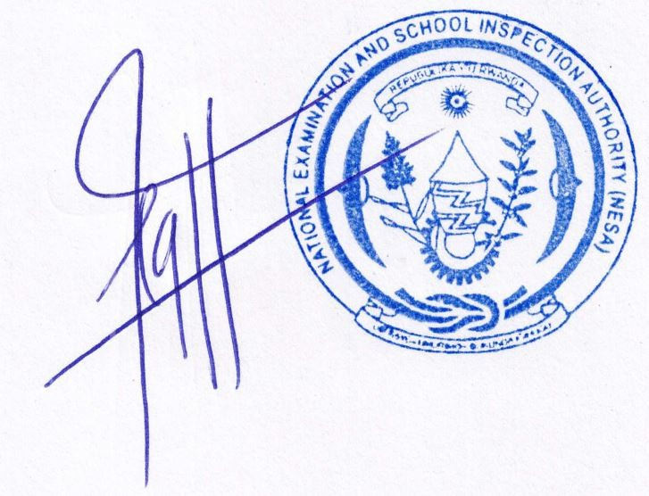

**NZEYIMANA Jean Claude**

Head of Basic Education and TVET Examinations Department.

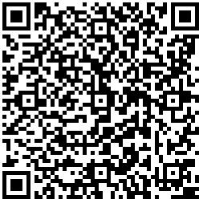National Examination and School Inspection Authority

P.O. BOX 1382,

Kigali, Rwanda

Toll Free: 9070

[info@nesa.gov.rw](mailto:info@nesa.gov.rw) [www.nesa.gov.rw](http://www.nesa.gov.rw/)